Assignment 2.1:

Task 1:

Check whether /user/acadgild directory exists or not in the HDFS.

/user/acadgild is present in the hadoop environment, but /user/acadgild/hadoop is not present. So we created the directory inside the /user/acadgild using the command hdfs fs –mkdir /user/acadgild/hadoop

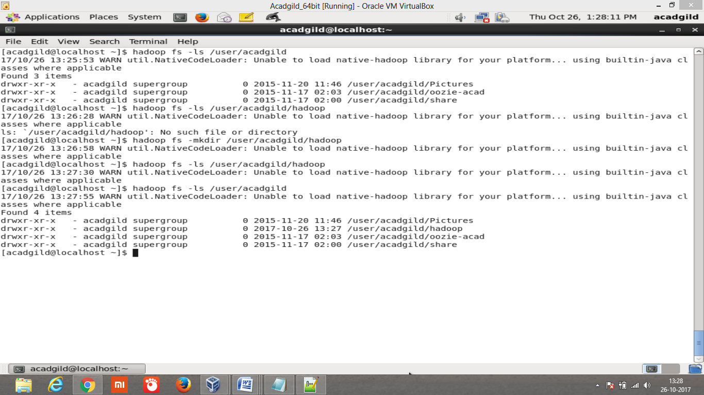

Task 2:

Create a file in HDFS under directory /user/acadgild/hadoop, with name word-count.txt.

Whatever we type on screen should get appended to the file.

